

Welcome to Middle School!

From School to the World: All Students Prepared for Productive Futures

Vision

Welcome to the NEW Isle of Hope K-8 School which contains 40 classrooms, 4 science labs, a media center, gymnasium, cafeteria, computer lab, and both music and art rooms!

We are so excited to show you our 5-star facility, where FIDDLER EXCELLENCE is our standard. MUCH hard work and preparation has gone into planning an amazing year for you! Expect GREAT things!

.Oliver@sccpss.com (6/7th Math)

To Ignite a Passion for Learning and Teaching at High Levels

Fantastic Fiddler Middle School

Staff Newsletter

Dolor

August 4, 2015

Mission

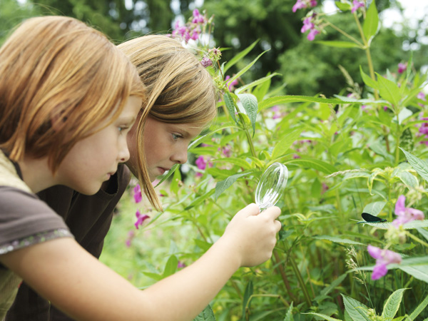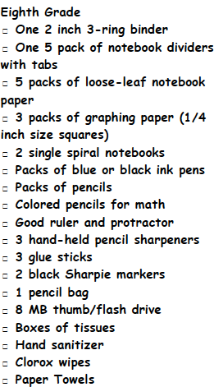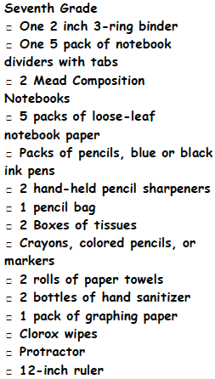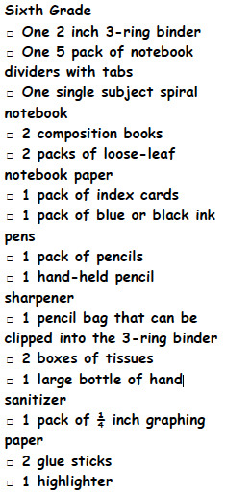

*Please turn in classroom school supplies to your homeroom teacher. Delete

Bell Times:

7:55 am – 2:55 pm

Breakfast in the Classroom:

7:25 am – 7:45 am

Arrival Time:

7:25 am

Dismissal:

2:55 pm

*Students should NOT be dropped off before 7:25 am.

### Class School Supplies

##### School Uniform Reminders:

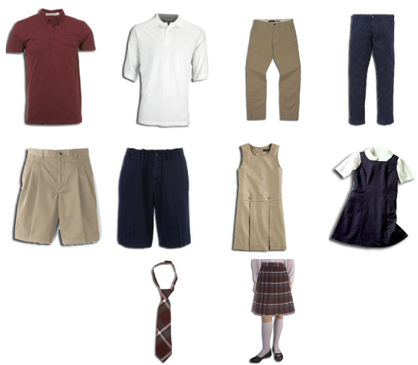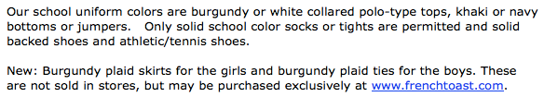

Please remember to tell all homeroom teachers how your child will be traveling to school and home each day (ex. school bus, walker, car rider). Either Mrs. Newman or Mrs. Wright must give permission for students to change busses once the school year begins.

REMEMBER: Students may NOT wear hoodies, according to district policy. While students may wear plain colored jackets/sweaters that zip up in the front to and from school, they must either be taken off or completely unzipped when in class. Shirts must be tucked in and belts must be worn at all times. NO crazy colored socks.

THIS WEEK…

*Students will be receiving student handbooks and initialing for receipt of them during homeroom.

*Code of Conduct books will be sent home and parents should sign the back of them and return to school.

Sed

Ipsum Augue?



*“In order to succeed, we must first BELIEVE that we can.”*

~ Nikos Kazantzakis

**Middle School Staff Team Members**

You can reach our staff members at the following email addresses:

Kevin.Goodnight@sccpss. (8th Math)

Mario.Mohorn@sccpss. (6/7th ELA)

Sydni.Bradley@sccpss. (6/7th ELA)

JenniferG.Clark@sccpss. (6/7th Math)

Laura.McNeill@sccpss  ( 6/8th Social Studies)

Linda.Oliver@sccpss.com (6/7th Math)

[Carolyn.Rethwisch@sccpss.com](mailto:Carolyn.Rethwisch@sccpss.com) (6/7th Science)

[Crystal.Hooker@sccpss.com](mailto:Crystal.Hooker@sccpss.com) (6/7th Social Studies)

[Karen.Hutchins@sccpss.com](mailto:Karen.Hutchins@sccpss.com) (6/8th Science)

[Melissa.Jenkins@sccpss.com](mailto:Melissa.Jenkins@sccpss.com) (8th ELA)

*Middle School Team Members will go over individual classroom policies and procedures with students during the first few days of school.

*Typically, during the school year, Communication Folders will be sent home with students on Wednesdays. Students will receive agendas to help them plan and organize upcoming important events.

*STUDENT ABSENCES – 15 unexcused absences (excused or unexcused) are permitted each year, however only 5 handwritten excuses per year are accepted.

*OPEN DOOR POLICY –

“We want our parents to feel that we are transparent but in order to eliminate classroom disruptions, we ask that parents make appointments and give us 24 hours notice before visiting a classroom.”

~Mrs. Newman